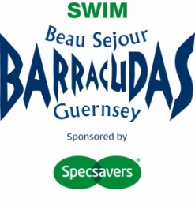
Beau Sejour Barracudas Swimming Club (Guernsey) LBG
(Affiliated to SER, HCASA, ASA)

The Specsavers Barracudas 28th Open Meet 2016
A Combined Level 2 and Level 3 Meet
17th, 18th & 19th June 2016
Level 2 Licence – 2SE160251
Level 3 Licence – 3SE160252

NAME OF SWIMMER: ________________________________ CLUB_________________________
CONTACT TEL NO: _________________________________ DATE OF BIRTH_________________

A.S.A. REGISTRATION NUMBER _____________________

Entry Forms to be into the Guernsey Swimming Club office by Tuesday 3th May by 7pm with entry fees

EVENT | EVENT LEVEL  Please circle level to be entered | ENTERED TIME
400 Freestyle | Level 2 only
50 Butterfly | Level 2/Level 3
100 IM | Level 2/Level 3
200 Butterfly | Level 2 only
100 Breaststroke | Level 2/Level 3
200 Backstroke | Level 2/Level 3
400 IM | Level 2 only
100 Butterfly | Level 2/Level 3
50 Backstroke | Level 2/Level 3
200 Freestyle | Level 2/Level 3
200 Breaststroke | Level 2/Level 3
100 Backstroke | Level 2/Level 3
100 Freestyle | Level 2/Level 3
1500 Freestyle Boys only | Level 2 only
800 Freestyle Girls only | Level 2 only
50 Breaststroke | Level 2/Level 3
200 IM | Level 2/Level 3
50 Freestyle | Level 2/Level 3
150 IM | For those entering disability category
No of events _______ at £5.50 per event. Please make cheque payable to GSC.

