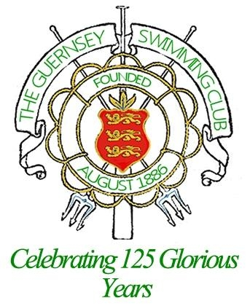

This years Annual Dinner Presentation night will be at the OGH Hotel (the Duke of Richmond is closed for refurbishment) and we will be having a special guest, the Lieutenant Governor to present our trophies. There is a limit of 150 persons. Arrival time is 7pm prompt and we will be seated by 7.30pm. The bar and disco will finish at 11.45pm.

Tables are of 10 and you are quite welcome to get together with friends and book one table. You will need to fill in one form for that table. If your children are not sitting with you please fill in a separate form and tell me who they would like to sit with. All children under 11 years old will be expected to sit with their parents.

The OGH have asked us to attach a wine menu for you to pre-order your wine for the evening, which will ensure it is ready for when you sit down and will help the evening go smoothly, payment of this will be on the night, please return the form with your food orders.

Your food menus must be returned to the office, with cheques payable to the Guernsey Swimming Club for the full amount by Friday 16th December 2011. No menus will be accepted without full payment.

Cheque for £…………………. Attached

If less then 10 people, who you would prefer to sit with.................................................

Name | Starter | Main | Dessert | u/12
Any problems please call Karen Girard 246928 or e-mail brigadier@cwgsy.net

